HealthApp Automation

Verification module

Pre-requisite:

As soon as you import project in eclipse, update the project using maven update option as below. This is to resolve issue if any maven dependency not downloaded properly:

1. Right click on project : Go to “Maven” : Select “Update Project”

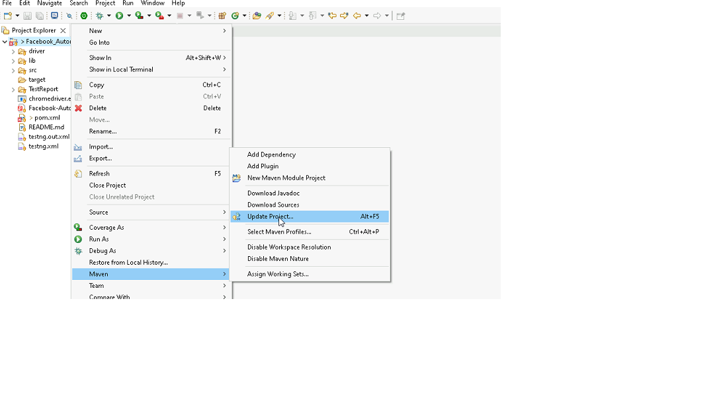

1. In Update Maven Project Box Select “Force Update of Snapshots/Releases” and click OK

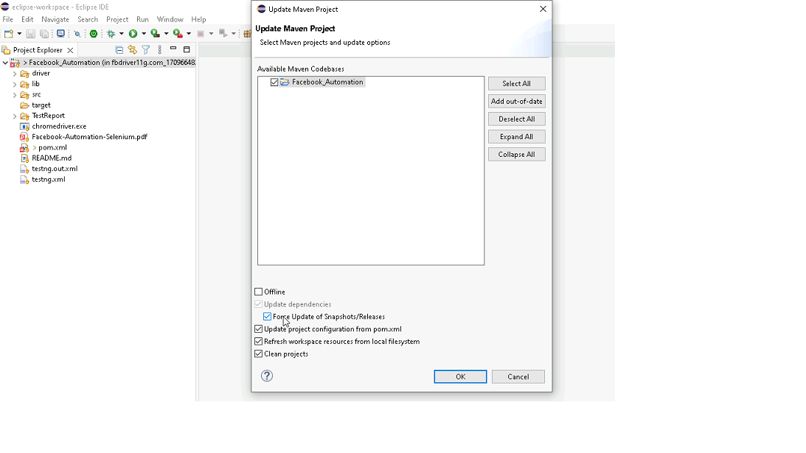

**Template Code Structure:**

1. Below are the packages and files you will be required to work upon.
2. Other Files and packages you can ignore.
3. In other Files and packages do not do any changes. It would affect your evaluation.
4. You are not required to work in “Test” Folder. Files there are non-editable. Editing those files and trying to save them will throw error and would affect your evaluation.

|  |  |  |
| --- | --- | --- |
| **Package** | **Class/File** | **Description** |
| src/main/java/coreUtilities/utils/ | FileOperations.java | 1. Contains methods to read from excel file. 2. Method is in templated form. 3. **You will be required to implement these methods as very first activity, because even URL to navigate to, is read using these methods.** |
| /src/main/java/pages | VerificationPage_PL2.java | 1. All core activities (mentioned in list above) to be performed here. 2. The comments associated with each templated method here describe the expectation. 3. You can define locators and xpath here. 4. Declare any variable/object you need to share data/status between different methods. 5. Do not modify the signature of methods declared here. 6. You can create additional supportive common methods in CommonEvents class. |
| /src/main/resources/ | Config.xlsx | URL to navigate to. Already URL is defined here |
| /src/main/java/coreUtilities/utils | CommonEvents.java | 1. Contains all common activities. 2. Certain templated common method declared here. 3. You implement them as per your need. 4. You can add any additional method for common activity here |
|  | Testng_1.xml | Execution needs to kick started from TestNG xml |

PROBLEM STATEMENT

Need to automate the following activities.

Key Activities to implement:

|  |  |  |
| --- | --- | --- |
| **#** | **Summary** | **Action** |
| **1** | Scenario: Verify the verification module is present. | **Precondition:** User Must be logged in to HealthApp System.   * Given Scroll & click till "Verification" menu on the side bar. * Then Verify that the user is able to navigate to "Verification" section |
| **2** | Scenario: Verify all sub-modules are displayed correctly after Clicking on the "verification" Module. | **Precondition:** User Must be logged in to HealthApp System.   * Given Scroll & click till "Verification" menu on the side bar. * Then Verify that the user is able to navigate to "Verification" section * Then Verify that "Inventory" button is visible. * Then Verify that "Pharmacy" button is visible. |
| **3** | Scenario: Verify the presence of Requisition tab in inventory section with all fields. | **Precondition:** User Must be logged in to HealthApp System.   * Given Scroll & click till "Verification" menu on the side bar. * Then Verify that the user is able to navigate to "Verification" section * Then Verify that "Inventory" button is visible. * Then Verify that "Pharmacy" button is visible. * And Click on "Requisition" under "Inventory" * Then Verify these elements are visible on the page Requisition, Purchase Request, Purchase Order, GR Quality Inspection, Ok, print, First, Previous, Next, Last, view, search bar, Requisition Status, Date range, Pending, Approved, Rejected |
| **4** | Scenario: Verify to navigate on another sub module after open the inventory module. | **Precondition:** User Must be logged in to HealthApp System.   * Given Scroll & click till "Verification" menu on the side bar. * Then verify that the user can navigate to "Verification" section * And click on "Pharmacy" tab * Then verify that the user can navigate to "Verification/Pharmacy/" section |
| **5** | Scenario: Verify to navigate on another sub tab after open the Requisition tab | **Precondition:** User Must be logged in to HealthApp System.   * Given Scroll & click till "Verification" menu on the side bar. * Then Verify that the user is able to navigate to "Verification" section * And Click on "Purchase Order" under "Inventory" * Then Verify that the user is able to navigate to "Verification/Inventory/PurchaseOrder" section |
| **6** | Scenario: Verify to search the data by picking the date filter | **Precondition:** User Must be logged in to HealthApp System.   * Given Scroll & click till "Verification" menu on the side bar. * And Choose the date from Jan 2020 to March 2024 * And Click on the "all" Radio button from List by Verification Status * And Click on OK button * Then Verify that all the dates present inside the requested date are within the range |
| **7** | Scenario: Verify the tooltip and it's text present on hover the mouse on "Star" | **Precondition:** User Must be logged in to HealthApp System.   * Given Scroll & click till "Verification" menu on the side bar. * Then Hover on the star and Verify tooltip text as "Remember this Date" |
| **8** | Scenario: Verify dates are remembered correclty | **Precondition:** User Must be logged in to HealthApp System.   * Given Scroll & click till "Verification" menu on the side bar. * Then Verify that the user is able to navigate to "Verification" section * And Choose the date from Jan 2020 to March 2024 * And Click on tooltip button * And Click on OK button * And Click on "Pharmacy" tab * And Click on "Inventory" tab * Then Verify that the date range remains the same |
| **9** | Scenario: Verify data range by Select "one week" option from drop down | **Precondition:** User Must be logged in to HealthApp System.   * Given Scroll & click till "Verification" menu on the side bar. * Then Verify that the user is able to navigate to "Verification" section * And Select 'Last 3 Months' option from the date range dropdown * And Click on OK button * Then Verify that all the dates present inside the requested date are within the range |
| **10** | Scenario: Verify following radio buttons are selectable:Pending, Approved, Rejected & All | **Precondition:** User Must be logged in to HealthApp System.   * Given Scroll & click till "Verification" menu on the side bar. * Then Verify that the user is able to navigate to "Verification" section * And Click on the "pending" Radio button from List by Verification Status * And Click on the "pending" Radio button from List by Verification Status * And Click on the "approved" Radio button from List by Verification Status * And Click on the "approved" Radio button from List by Verification Status * And Click on the "rejected" Radio button from List by Verification Status * And Click on the "rejected" Radio button from List by Verification Status * And Click on the "all" Radio button from List by Verification Status * And Click on the "all" Radio button from List by Verification Status * And Click on the "pending" Radio button from List by Verification Status |
| **11** | Scenario: Create and Verify a Purchase Request in Inventory | **Precondition:** User Must be logged in to HealthApp System.   * Given Navigate to the Internal section under Inventory. * And Click on Purchase Request. * And Click on the Create Purchase Request button. * And Fill in the required fields to create a Purchase Request. * And Click on the Request button. * Then Verify that the Purchase Request has been successfully created. |
| **12** | Scenario: Verify Purchase Request in Verification Module | **Precondition:** User Must be logged in to HealthApp System.   * Given Navigate to the "Inventory" section under Verification. * And Click on Purchase Request. * Then Verify that the status of the Purchase Request is "Pending" in the list. |
| **13** | Scenario: Approve the Purchase Request and Verify Status | **Precondition:** User Must be logged in to HealthApp System.   * Given Navigate to the "Inventory" section under Verification. * And Click on Purchase Request. * When Click on the View button under the action column for the Purchase Request. * And Approve the Purchase Request. * Then Verify the success message confirming the approval. * And Click on the Approved radio button. * Then Verify that the status of the Purchase Request has changed to Approved. |
| **14** | Scenario: Verify Reject All button without filling remark field | **Precondition:** User Must be logged in to HealthApp System.   * Given Navigate to the "Inventory" section under Verification. * And Click on Purchase Request. * When Click on the View button under the action column for the Purchase Request. * And Click on Reject All button. * Then Verify a popup message should appear stating Remarks is compulsory for cancellation. |
| **15** | Scenario: Reject the Approved Purchase Request and Verify Status | **Precondition:** User Must be logged in to HealthApp System.   * Given Navigate to the "Inventory" section under Verification. * And Click on Purchase Request. * And Click on the Approved radio button. * When Click on the View button under the action column with status approved for the Purchase Request. * And Click on Reject All button with remarks. * And Click on the Rejected radio button. * Then Verify that the status of the Purchase Request has changed to Rejected. |
| **16** | Scenario: Take Screenshot of the current page | **Precondition:** User Must be logged in to HealthApp System.   * Given Navigate to the "Inventory" section under Verification. * And Click on Purchase Request. * Then Take screenshot of the current page. |

NOTE: "Please do not delete any file in the “src” folder.  But you are free to add any other file.

Expectations:

1. Learners should write automation scripts using Java and Selenium to automate all the steps in the above question. In other words, the automation script should perform all the mentioned steps.
2. Learners should not use any tools to create the xpath. They should develop the xpath/cssselector on their own.

IMPLEMENTATION/FUNCTIONAL REQUIREMENT

* 1. **CODE QUALITY/OPTIMIZATIONS**
     1. Associates should have written clean code that is readable.
     2. Associates need to follow SOLID programming principles.

# EXECUTION STEPS TO FOLLOW

1. **You are mandatory required to run test cases for applications before final submission. Without which project evaluation will not happen.**
2. **You can launch test cases any time as follows: Right click on testng.xml and run TestNGSuite**

|  |
| --- |
|  |

1. **Before final submission, you are also required to push your code to GIT. Following are the steps to follow:**

|  |
| --- |
|  |

In your project folder, you will find a batch file named git_commands

|  |
| --- |
|  |

Double-click the batch file to run it. It will run the commands to push your code to GIT.

|  |
| --- |
|  |

===============================================================================

All the Best